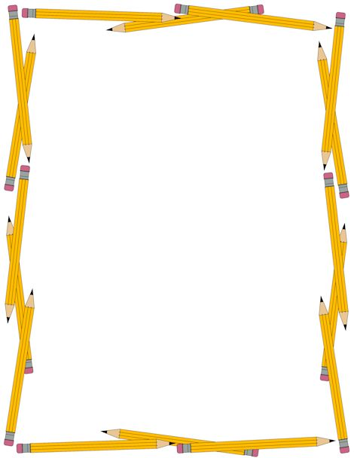

**Shannon Ewing**

**267-251-9627**

**Shannon_ewing@comcast.net**

**Christina Mariani**

**215-847-9665** [**marianiC729@gmail.com**](mailto:marianiC729@gmail.com)

**Backpack Ministry**

Each Auxiliary has been given a start from the NJ State Council with one backpack. Please fill these bags and more as you can to support this great need. Remember that these backpacks are given to each Diocese within NJ to be distributed to children who enter the various programs and shelters, who, unlike your own children heading off to school, would not be able to afford a new backpack and supplies.

**Suggestions**

Binders Notebooks Folders

Index Dividers Filler Paper Mini-stapler

Staples Stapler Remover Pens

Safety Scissors Pencils Erasers

Colored Pencils Markers Highlighters

Sharpener Sticky Notes Calculator

Tape Crayons Glue Sticks

Construction Paper Paper Clips White Out

“NO FOOD ITEMS PLEASE”

**DO NOT FILL BOX TOO HEAVY - IF YOU CAN’T LIFT IT NEITHER CAN THE COMMITTEE OR RECIPIENTS!!!**

Consider putting a note with the name of your auxiliary so that the recipients know who made the donation and that you are keeping them in your prayers.