May – Our Lady of Fatima (Church celebrates on May 13th)

PRAYER SERVICE for Our Lady of Fatima

Leader: Let us reflect upon Mary, Our Lady of Fatima. Our Lady appeared to three shepherd children, Lucia, Francisco, and Jacinta, near Fatima, Portugal on the 13th of each month, from May to October,1917. The apparition of Mary in August was delayed until the 19th of that month because the children were imprisoned on the 13th. The 100th anniversary of Mary’s appearances at Fatima was celebrated in 2017, and her request of the children is still her request of us, namely to make reparation for offences committed against God and against Her Immaculate Heart.

Leader: Prior to Mary’s appearing to the children at Fatima, an angel of God appeared to them three times to prepare the children for Mary’s arrival.
- At the angel’s first apparition, he taught the children this prayer, which is known as the Pardon Prayer:
All: My God, I believe, I adore, I hope and I love you! I ask pardon of You for those who do not believe,
do not adore, do not hope and do not love You.
Leader: We should pray the Pardon Prayer daily for faith, hope and charity to be renewed in our world.
- At the angel’s second apparition, he told the children:
“Make of everything you can a sacrifice, and offer it to God as an act of reparation for the sins by which He is offended, and in supplication for the conversion of sinners. You will thus draw down peace upon your country.
I am its Angel Guardian, the Angel of Portugal. Above all, accept and bear with submission, the suffering which the Lord will send you.”
Now, we may not be sent down sufferings as the three children were, but we can offer the sufferings that we do undergo, up to God as a sacrifice and as an act of reparation, as the children were told to do.
- At the angel’s third apparition, the children were taught this prayer that we are encouraged to pray daily:
All: Most Holy Trinity, Father, Son and Holy Spirit, I adore You profoundly, and I offer You the most precious Body, Blood, Soul and Divinity of Jesus Christ, present in all the tabernacles of the world, in reparation for the outrages, sacrileges and indifference with which He Himself is offended. And through the infinite merits of His most Sacred Heart, and the Immaculate Heart of Mary, I beg of You the conversion of poor sinners.
Leader: At this apparition, after teaching the children this prayer, the angel held up a chalice and Host and offered Holy Communion to the children. Only Lucia had already made her first communion, so she received the consecrated Host, while Francisco and Jacinta drank from the chalice that the angel presented to them. This was their first Holy Communion. After communion, the angel repeated the prayer that he had just taught to them. Also, while the chalice and Host were suspended in the air prior to, and following communion, the angel bowed profoundly. We can show this same reverence at mass, during Holy Communion, and during Eucharistic Adoration, either before a tabernacle or during exposition of the Blessed Sacrament.
By now, the children were ready to see Mary.

At the first apparition, Mary told the children that she was from heaven. She asked the children to “pray the rosary every day to obtain peace for the world, and the end of the war”. Mary taught the children at each apparition and gave them visions of heaven and hell. She entrusted the children with three secrets, and she requested the consecration of Russia to her Immaculate Heart. This consecration was attempted by several popes, but was finally fulfilled by Pope Saint John Paul on March 25, 1984, the Solemnity of the Annunciation. At the final apparition in October 1917, when tens of thousands of people had gathered in anticipation of Mary’s appearance, The Miracle of the Sun occurred, as promised by Mary so that all could see and believe. Indeed, it should be remembered that during each of her six apparitions, Our Lady repeated the request of her children to pray the rosary every day for world peace. During the sixth apparition, she referred to herself as the Lady of the Rosary. During the June apparition, Mary taught the children this prayer, which she requested be recited at the end of each decade:
All: “O my Jesus, forgive us, save us from the fire of hell. Lead all souls to heaven, especially those who are most in need.”
Leader: During the July apparition, and then again in more detail when Mary appeared privately to Lucia, who was now Sr. Lucia, on December 10, 1925, Our Lady requested the devotion of the First Five Saturdays. In the June vision of 1917 and again in 1925, Mary’s heart was encircled by a crown of thorns.

As we conclude this prayer service, let us recite the Litany of Our Lady of Fatima:
Leader: All Respond:
Our Lady of Fatima, pray for our dear country.
Our Lady of Fatima, sanctify our clergy.
Our Lady of Fatima, make our Catholics more fervent.
Our Lady of Fatima, guide and inspire those who govern us.
Our Lady of Fatima, cure the sick who confide in thee.
Our Lady of Fatima, console the sorrowful who trust in thee.
Our Lady of Fatima, help those who invoke your aid.
Our Lady of Fatima, deliver us from all dangers.
Our Lady of Fatima, help us to resist temptation.
Our Lady of Fatima, obtain for us all that we lovingly ask of thee.
Our Lady of Fatima, help those who are dear to us.
Our Lady of Fatima, bring back to the right road our erring brothers.
Our Lady of Fatima, give us back our ancient fervor.
Our Lady of Fatima, obtain for us pardon of our manifold sins and offenses.
Our Lady of Fatima, bring all men to the feet of thy Divine Child.
Our Lady of Fatima, obtain peace for the world.

O Mary conceived without sin, pray for us who have recourse to thee. Immaculate Heart of Mary, pray for us now and at the hour of our death. Amen.

Let Us Pray: O God of infinite goodness and mercy, fill our hearts with a great confidence in Thy dear Mother, whom we invoke under the title of Our Lady of the Rosary and our Lady of Fatima, and grant us by her powerful intercession all the graces, spiritual and temporal, which we need. Through Christ our Lord. Amen.

Remind everyone to pray the Rosary daily!

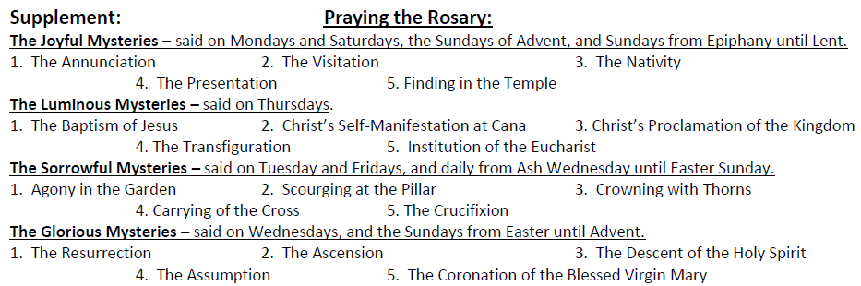

Prayer Before the Rosary:
Queen of the Holy Rosary, You have deigned to come to Fatima
to reveal to the three shepherd children the treasures of grace hidden in the Rosary.
Inspire my heart with a sincere love of this devotion,
in order that by meditating on the Mysteries of our Redemption which are recalled in it,
I may be enriched with its fruits and obtain peace for the world,
the conversion of sinners and of Russia, and the favour which I ask of you in this rosary. (Mention your request.)
I ask it for the greater glory of God, for your own honour,
and for the good of souls, especially for my own. Amen.
Following Each Decade:
O my Jesus, forgive us our sins, save us from the fire of hell,
take all souls to heaven, and help especially those most in need of Your mercy.
Following Five Decades:
Hail, Holy Queen, Mother of Mercy, our life, our sweetness, and our hope.
To you do we cry, poor banished children of Eve.
To you do we send up our sighs, mourning and weeping in this valley of tears.
Turn then, O most gracious advocate, your eyes of mercy toward us;
and after this our exile, show unto us the blessed fruit of your womb, Jesus.
O clement! O loving! O sweet Virgin Mary!
V. Pray for us, O Holy Mother of God.
R. That we may be made worthy of the promises of Christ.
Prayer After the Rosary:
O God, Whose only-begotten Son, by His Life, Death, and Resurrection,
has purchased for us the rewards of eternal life;
grant, we beseech You, that,
meditating upon these Mysteries of the Most Holy Rosary of the Blessed Virgin Mary,
we may imitate what they contain and obtain what they promise,
through the same Christ our Lord. Amen.
V. May the divine assistance remain always with us.
R. Amen.
V. And may the souls of the faithful departed,
through the mercy of God, rest in peace.
R. Amen.

Sources: “Prayer Service for Our Lady of Fatima” is excerpted from http://www.cwlsk.ca/extras/Prayer%20Service%20for%20Our%20Lady%20of%20Fatima.pdf
- Prayers and information: Fatima for Today – The Urgent Marian Message of Hope, Fr. Andrew Apostoli, C.F.R.; Ignatius Press, San Francisco, 2010.
- Pray the Rosary, Catholic Book Publishing Corp., New Jersey, 2008.

